**git <git-options> <command> <command-options> <operands>**

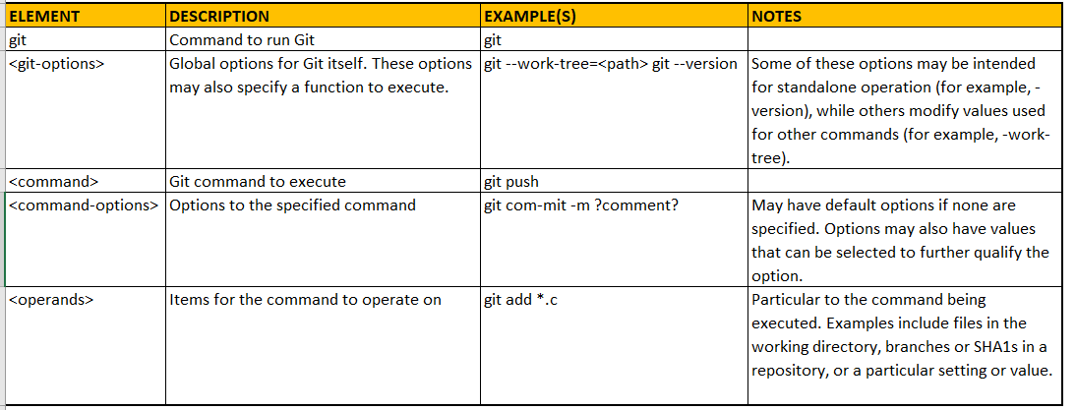

**Auto-Complete**

When you start typing a command or an argument to a command, Git has a helpful auto-completion feature (if enabled) that can do two things:

* Provide valid values for the commands or arguments that could complete the text you're typing—if there is more than one valid option.
* Automatically complete the command or argument that you're typing—if there is only one valid option.

Following are a couple of examples. The first one is for a command. If you type git c and then press the Tab key, nothing happens because there's more than one command that starts with *c*.

If you press the Tab key a second time (before typing anything else in between), Git helpfully displays all of the commands that start with *c*. In this case, it also scrolls that list up and leaves you at a prompt where you can continue typing the chosen command.

$ git c

checkout citool commit

cherry clean config

cherry-pick clone

$ git c

Here's another example, where you narrow the available commands with more letters.

$ git co <TAB><TAB>

commit config

$ git c

If you type enough letters to uniquely identify only one possible choice, then pressing the Tab key auto-completes the command for you because there's only one option. For example, git con <TAB> yields git config.

This also works for arguments to commands. Typing git config --l <TAB> <TAB> gives the suggestions: --list --local. Typing either git config --l or git config --li <TAB> yields git config --list.

##### Note

When attempting to use auto-complete for an option, make sure that you have started the option with the double-hyphen (--) syntax and not just a single hyphen.